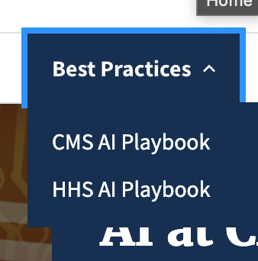

Best Practices PAGE
Like any technology, AI can be helpful, harmful, or ineffectual. The CMS AI Playbook shares best practices for applying AI to ensure that CMS stakeholder needs are met. The HHS Trustworthy AI Playbook explains how agencies across the department can derive maximum value from AI while mitigating risks.
For landing Page:
What is the page about? A blurb about each sublink.

At CMS, AI has the power to reshape the way we use data to make decisions. In fact, there is no better place to implement AI technology. AI is driven by data, and CMS is an extremely data-rich agency. There are nearly 150 million Americans enrolled in Medicare, Medicaid, and the Child Health Insurance Program. We house patient and provider claims, enrollments, and medical records, along with internal data such as budget documents and contractor data.
AI can find patterns in this data that may not be accessible via manual methods of analysis, either because it would take too long or because a human can only process so much information at once. Aside from sorting the data, AI can help us to learn from it. Further, AI can automate labor-intensive manual processes, find operational efficiencies, provide insights from information, make predictions, identify disparities, and reveal new ways of solving problems.
In short, AI is an emerging technology that should have a wide impact throughout CMS and ultimately, for the American public. These impacts include resource savings and better health outcomes.
To implement AI, and to do so responsibly, we must educate our workforce, share knowledge, be transparent about our use of data, follow ethical standards, and experiment with new technologies.
That is why we have created this website. It offers a starting point for anyone interested in any aspect of AI at CMS.

CMS AI Playbook –
Does AI sound as overwhelming as it does promising? Don’t worry. The CMS AI Playbook is an easy-to-follow guide that walks stakeholders through the process of conceiving, developing, and implementing AI solutions at CMS. It covers design principles, research and development, engineering, and procurement.
The guidelines in the AI Playbook cover the technical aspects of development as well as human factors. They are not just for software engineers. They are invaluable to anybody at CMS who believes an AI solution can improve their team or provide value to their customer. Successful application of AI must take into account the customer perspective; it requires well-tailored, high quality data sources; it must be secure; and last but not least, it must follow rigorous ethical standards.
To learn more about how to responsibly, effectively, and efficiently devise AI solutions, check out the <link>CMS AI Playbook<link>.

Now: Link to PDF
Future: Hardcode content in markdown.
Rick with dreamweaver.

HHS Trustworthy AI Playbook
There are several ethical considerations to address when designing AI-enabled systems. These considerations are explained in the U.S. Department of Health and Human Services’ Trustworthy AI Playbook, which was released in September 2021. The Handbook covers six overarching principles of Responsible AI, based on Executive Order 13960, “Promoting the Use of Trustworthy Artificial Intelligence in the Federal Government, and OMB Memorandum M-21-06, “Guidance for Regulation of Artificial Intelligence Applications.”
The playbook demands that AI adhere to six principles. It should be fair and impartial; transparent and explainable; responsible and accountable; robust and reliable; private; safe and secure. Additionally, the playbook lists concrete steps we can take to encode these principles while designing AI solutions. Some examples are:
- Obtaining consent from patients for the use of mobile data that will be used in an app to track disease symptoms (Privacy)
- Including data encryption, user authentication, and other applicable security controls in a NLP-based AI application that interprets handwritten medical records (Safe/Secure)
- Establishing clear roles and responsibilities for people involved in creating AI solutions, especially so that specific people are accountable when solutions do not perform adequately (Responsible/Accountable)
The six principles of Responsible AI must be tended to throughout the data life cycle, from initial conception of a solution to its operation and maintenance. For more detailed information, refer to the Trustworthy AI Playbook.

Now and Future: Link to PDF https://www.hhs.gov/sites/default/files/hhs-trustworthy-ai-playbook.pdf

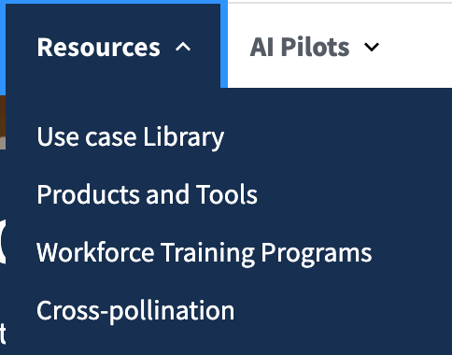

Resources Landing Page
Blurb about each child

List of actual resources:
Link to Data Summit page(s)
Link to GovCIO article from Convergence
Link to Convergence page(s)
Link to RapidATO Article
Link to Data Science Track Announcement
Link to AI Pilots Program Announcement
Link to AI Playbook Announcement

Use Case Library
AI will play a major role in the future of CMS, but it is also already here. This page details AI products that are revolutionizing CMS operations. Keep reading to learn more about how CMS is applying AI techniques to increase efficiency; improve health outcomes; and detect waste, abuse, and fraud.
Vendors should be part of the use cases.
Andrés is thinking we can link to Rapid ATO.
Andrés Volunteers to work on this section.
MVP: Can we add a list of vendors that mentioned in the use cases??? Let’s avoid it, harder to mantain this site with vendors moving in and out. They can always mention them in things like attached articles.

Consists of the following pages:
- Use Case Library Index Page
- Individual Use Case Page

Use Case Library Index Page
- Hero Image
  - Text: “AI Use Case Library”
  - Background image
- Section
  - Title: “Sharing Artificial Intelligence use cases and resources across CMS.”
  - Description: “The Use Case Library is built with the primary purpose of assembling an extensive collection of AI Use Cases across CMS in order to house examples of what is possible across the many applications of AI tools and techniques, and as a mechanism for to understand and learn from the range of public AI system development at CMS. Use the filters below to explore what has been done across various techniques, environments, agencies, lifecycles, etc.
- Content:
  - Consists of List of Uses cases:
    - Title: “Use Case Title”
    - Date published in the website: “Published Date: mm/dd/yy”
    - Description: “One or two sentence description of the project”
    - Call to Action: Read use case
    - Related Keywords / meta-tags: terminology related to this use case.
      - Meta tags:
        - Ai Lifecycle stage
          - Pilot
          - Production
          - Prototype or proof of concept
          - Research project: Research and testing
        - AI/ML techniques applied
          - Autonomous systems
          - Image recognition
          - Intelligent automation
          - Natural language processing or generation
          - Pattern and anomaly detection
          - Predictive analytics and decision making
          - Recommendations and personalization
        - Benefits
          - Reduce burden
          - Decrease cycle time
          - Improve customer service
          - Increase accuracy
          - Increase compliance
          - Increase outputs
          - New service / capability
        - Related to:
          - Acquisition and procurement
          - Aerospace
          - Agriculture
          - Cyber security
          - Grants management
          - Health and medicine
          - Policy and regulation
          - Social and welfare issues
          - Tax, trade, and economy
          - Transportation and infrastructure
        - Use of PHI or PII
          - PHI
          - PII
          - Sensitive information
          - Non-sensitive information

Use Case Library Index Page - Template
- Content
  - Title: “Lorem Ipsum”
  - Description: “Lorem Ipsum”
  - Related Keywords / meta-tags:
  - Related Articles and Links

Use Case Library Index Page - Rapid ATO
- Content
  - Title: “CMS Rapid ATO”
  - Description: “The goal of CMS Rapid ATO is to provide the CMS Security and Privacy community with the information and tools to plan, launch and maintain secure, compliant software. It focuses on reducing the burden of security planning and applies AI to identify and share vetted reusable security compliance implementations for common technology stacks.”
  - Related Keywords / meta-tags: Pilot, NLP, Recommendations and personalization, OIT, Cyber security, Increase compliance, Reduce burden, Decrease cycle time
  - Related Articles and Links
    - Link to: Rapid ATO Article PDF
    - Link to: ato.cms.gov

Products and Tools
Add them below:
What’s the scope for this? What kind of products do we leave out? Anything we put looks like an endorsement (full support). Is this for Developers or regular folks//both. What info would help them here. What kinds of tools are there?
- WHITE LISTED
- Knowledge Map / Astro
- Speak to the types of tools, rather than necessarily endorsing specific tools. Talk about considerations when selecting tools. Best practices.

Workforce Training Programs
RENAME to “Training Programs”

Page should contain:

Workforce Resilience Program blurb: Rick
Reference HCD Track and others in relation to AI.

Workforce Resilience (WR) is the CMS program designed to cultivate a resilient and sustainable workforce for the future. The intent is to both cultivate a culture of learning and create a space for everyone to learn, innovate, and grow professionally. This way, we can grow to provide even more value to the millions of Americans who depend on us for their healthcare. Much of that value will be generated by AI and related concepts. WR offers learning modules in Human-Centered Design; Data Science; CMS Cloud; and AI and ML (forthcoming).

Data Science Track Blurb: Xingjia
In the era of Big Data, it’s not hard to find information. Turning that information into knowledge, however, is another story. That’s what data science is all about. It’s an interdisciplinary field that uses scientific methods, processes, algorithms, and systems to extract insights from noisy, structured and unstructured data, and to apply those insights across a broad range of applications.
Data science is reshaping healthcare in multiple applications, for example by improving diagnostic accuracy and optimizing clinical performance. CMS oversees multiple federal healthcare programs and generates an extensive amount of data daily that, when understood, can further streamline effective healthcare delivery to the American public. In sum, data science practices can help us reduce work burdens, make better decisions, and optimize solutions for our stakeholders.
The practice of data science entails gathering data, examining it, sorting it, modeling it, interpreting it, and visualizing it. The Data Science Track of WR is your first step to empowering yourself with knowledge of these techniques.

The Data Science Track will include three phases that will cater to different learning needs.
- The Awareness phase: learning about Data Science
o Scope of Data Science
o Application of Data Science
o The Life cycle of Data Science projects and common tools
o CMS data and data literacy
- The Competency phase: training your skills
o Database and SQL
o Data Manipulation and Analysis
o Data Visualization and Storytelling
- The Engagement phase: getting your hands dirty
o Capstone projects as opportunities for real-life applications
Delivery format: self-paced learning materials combined with instructor-led courses
Timeline: Starting FY2022
Contact Us:
Slack channel: #data-science-track (in CMS workspace)
Email: datascience@cms.hhs.gov

Pluralsight Blurb: Pluralsight is an online educational platform that we use for our WR program. that we use for our WR program. It allows us to combine pre-packaged educational materials with CMS-designed, CMS-specific content. Pluralsight is an important tool for creating a robust learning community at CMS where you are empowered to acquire industry knowledge at the foundation of human-centered design, agile, and lean methodologies. Start your learning journey and unlock your potential!

Future: Maybe HHS Training

Community [Prev. Cross Pollination]
RENAME Cross-Pollination to “Community”
Links to Slack Channels #ai_community???
Links GSA Communities - Email listServ (OMG Leila is STUNNED that these still exist)

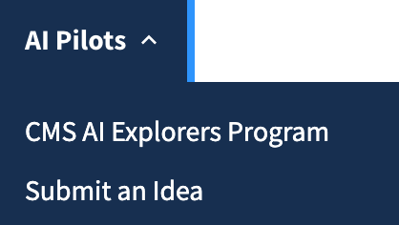
Xingjia

AI Pilots Landing Page

CMS AI Explorers Program
The AI Explorers Program is an exciting opportunity for CMS employees to prototype AI applications for testing and potential development. Each quarter for two years, OIT will accept proposals for projects that apply AI and ML techniques related to CMS's mission and to the applicant's team functional area. From these submissions, OIT executive leadership will fund two projects per quarter up to $250,000 each. Along with funding, awardees will receive support such as matching with pre-qualified vendors. They will have three to six months to test their hypotheses.
The goals of the pilot are to:
- bootstrap both proofs of value and initial Minimum Viable Products
- encourage applicants to get acquainted with AI/ML and grow their technological skill sets
- test out hypotheses using Agile methodologies prior to a large-scale development effort
- develop incremental expertise, and boost confidence in the AI domain
- establish a baseline framework on how to bring an AI/ML project from ideation to production readiness within CMS
Background
The private sector has adopted AI technologies much more rapidly than government agencies. To accelerate AI research and applications throughout the federal government, Congress passed The National AI Initiative Act of 2020 (DIVISION E, SEC. 5001), which became law on January 1, 2021. The National AI Initiative provides a coordinated program across the entire Federal government to accelerate AI research and develop applications that will increase the Nation’s economic prosperity and national security.
AI Explorers is a major effort by OIT to comply with the NAIIA, reducing barriers to entry for AI projects at CMS. By increasing the application of AI across components, we can increase value to our customers, to healthcare providers, to Medicaid and Medicare enrollees, and to the American public
Deadlines
The program accepts project idea submissions on a quarterly basis throughout FY2022.
If you've applied in previous rounds, your application is still active for re-consideration and a resubmission is not needed
Eligibility
Any federal CMS employee is eligible to apply.

Submit an Idea (General IDEA Submission)
NOW: Submit Link to Qualtrics Survey

Future:
Maybe remove for MVP.
RENAME to “Suggestion Box”
Use this to prep the director so that anyone external can submit ideas so decision makers can use this ideas for contracting/funding/projects for the future.

This needs some additional thinking and understanding. Process/People/Tech.

Create New Qualtrics Survey that serves as a suggestion box

Design a left-side box that can be included in Jekyll across the site:
Do you have an idea or an existing AI project you would like to share?
Showcase your successful use cases here!
We'd love to speak to you about including it in our growing library.
“Suggest a Use Case” [Hyperlink to Form]
You can also email us.
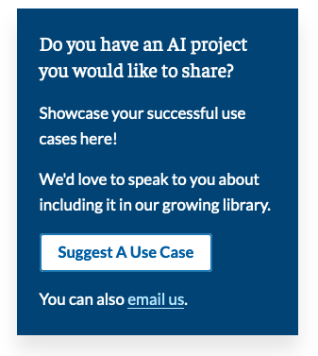

==================================================
AI Explorers Program
Background
In CMS, AI is an emerging technology with various level across components. To create opportunities to explore AI and decrease the barriers to entry and pain points for AI projects, we are launching this AI Explorers program in CMS, open to all federal employees. This program will provide opportunities for Federal employees to learn about AI and test AI hypotheses through the funding and mentorship of small AI related pilots.
Program Highlights
· Encourage interested federal employees to submit proposals for AI hypotheses they want to explore through a pilot.
· A vetting process selects submissions for execution
· Funding is made available by OIT for up to $250K per pilot
· 6-8 Pilots per year. Open submission quarterly throughout the FY2022
· Components manage their own pilots with OIT mentorship and assistance.
· Knowledge gleaned is shared across CMS
Key points
· Starting time: FY2022
· Funding limit: up to $250,000 for each project
· Time span: 3-6 months for each funding project
Submission
· Submit your idea here: https://cms.gov1.qualtrics.com/jfe/form/SV_8jqSX0YFO2SU5Yq
· Deadline for submission*: Feb 18th, 2022
*accepting submission on a quarterly basis.
What to expect after submission
· First screen results within 3 weeks after close of submission
· Participant past the first screen will have opportunity for a short presentation
· Final award will be announced within 8 weeks after close of submission
Contact Us:
Slack channel: #cms_ai_explorer_program
Email: ai-pilots@cms.hhs.gov

Data Science Track
(through Workforce Resilience Program in OIT)

News feed?
AI Explorer Q&A: https://content.govdelivery.com/landing_pages/33211/aee5d08d465777bb3e7d5be475a132da
Data Science Myths and Truths: https://content.govdelivery.com/landing_pages/33210/b9742c33a1441e41c04bd6a1498884e8
Astro: https://content.govdelivery.com/landing_pages/33110/145a5f29a78463f723bab725f557a921
What’s New in Data Science?: https://content.govdelivery.com/landing_pages/33108/fd3483a6770951da2adb7ee78700f62f
Data Science Literacy: https://content.govdelivery.com/landing_pages/33081/57f264400409f0d7da56be7301ccd229
Fighting Fraud: https://governmentciomedia.com/cms-using-analytics-machine-learning-fight-fraud
Artificial Intelligence (AI) in Action: The Story of RaidATO: https://cmsitsm.servicenowservices.com/connect?page=content-item&sys_id=4498507d1b07f014ea70eb9ce54bcb3c
Talking AI with James DelAguila: https://www.youtube.com/watch?v=cxSl73lHBxY

Fact Sheets
Life Cycle of Data Science: https://content.govdelivery.com/attachments/USCMS/2022/02/24/file_attachments/2085309/LifecycleofDataScience.pdf
Data Science/AI/ML One pager

Multimedia
Dr. Data Meets AI: https://www.youtube.com/watch?v=k6BUyAZdWzc

